ABC Corporation Overall Analysis

Introduction
This document outlines the business scenarios and Power BI use cases implemented for ABC Corporation.
The report consists of three analysis pages:
- Customers Analysis
- Products Analysis
- Orders Analysis
Each page provides detailed insights using interactive visuals, slicers, drill-down views, and tooltips.
Additional visuals have been included to enrich the dashboard experience and improve business understanding.

Customer Analysis:
This page shows customer-centric KPIs such as total customers, total orders, top customer, monthly order trends, and daily order breakdown.
Filters for Year, State, and Customer Name allow users to slice the data dynamically.
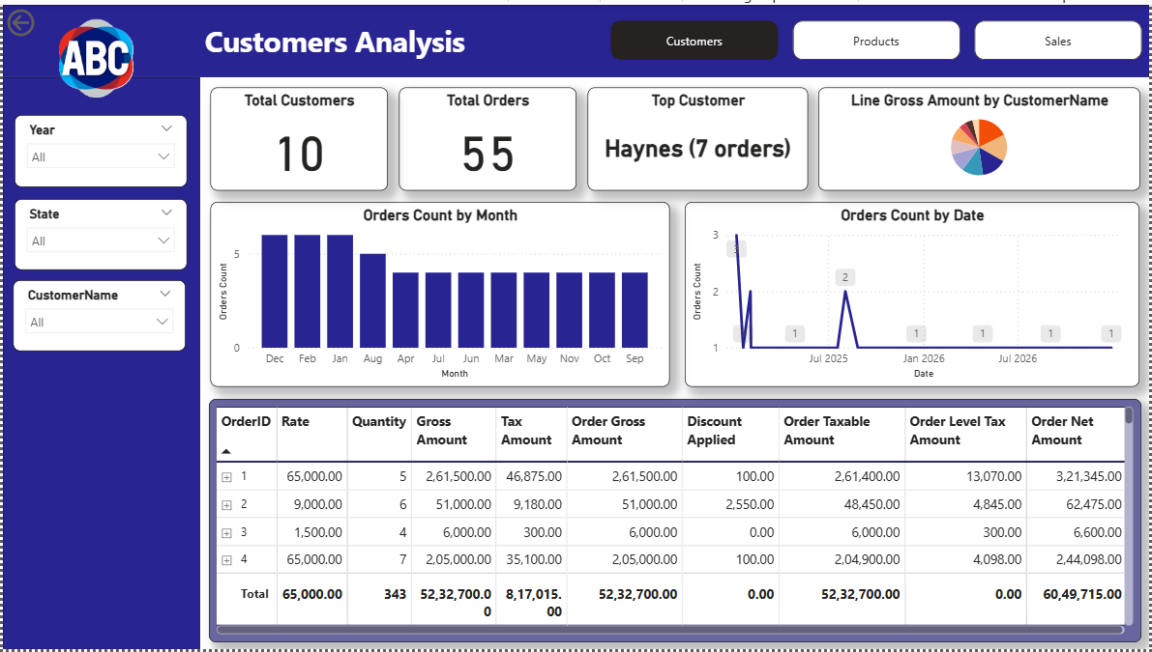

Products Analysis:
This page provides a detailed view of product rates, tax applicability, stock availability, and product order volumes. It also highlights the count of taxable vs. non-taxable products.
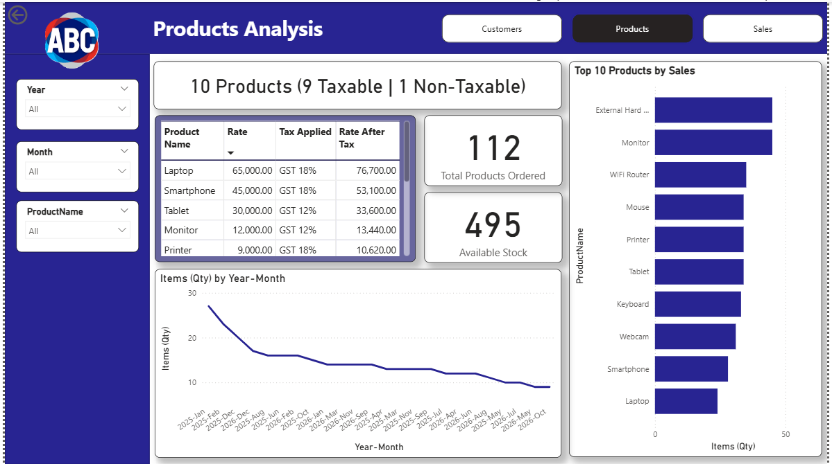

Orders Analysis:
This section displays order-level insights, total sales, total discount, location-wise orders, product demand forecasting, and reasons for non-taxable orders.
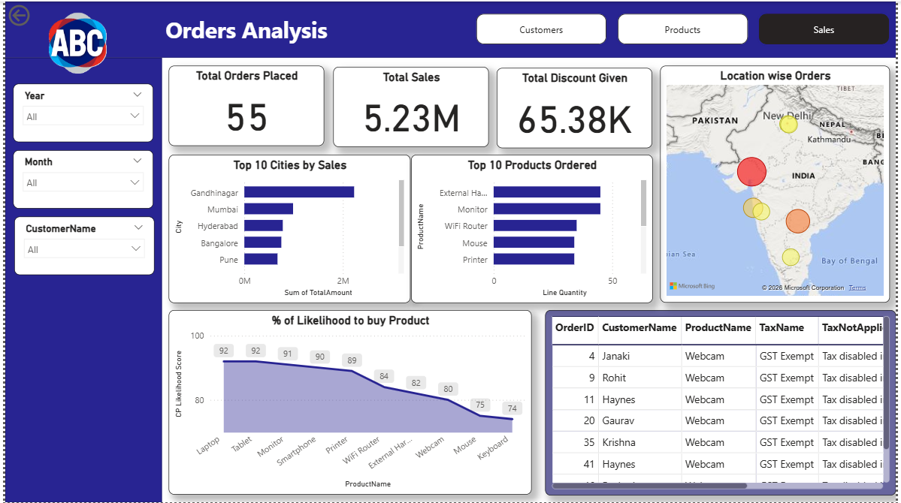

Use Case Explanations:
1. List out statistical report for location wise customers and their total number of orders been placed Daily & Monthly:
When a user selects Year, State, or Customer Name from the slicers:
- The bar chart (Orders Count by Month) displays the monthly order count.
- Selecting a specific month updates the line chart (Orders Count by Date) to show daily order trends for that month.
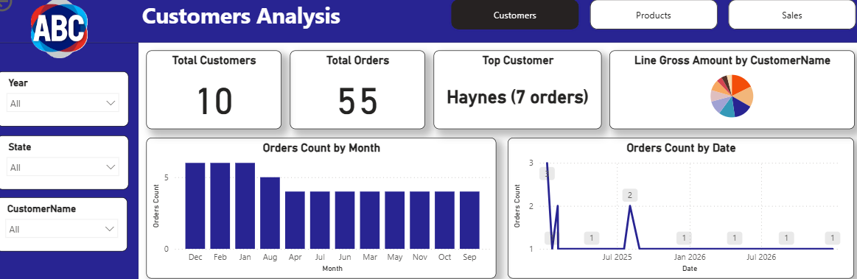

2. List out the Tax applicable on products and showcase the Tax applied on product's defined rate:
A table visual displays:
- Product Name
- Base Rate
- Applied Tax (GST %)
- Rate After Tax
A highlighted row indicates products where tax is not applicable.
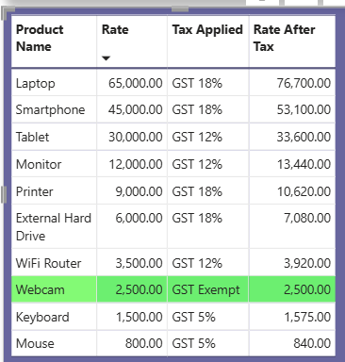
- Develop a customer-based Orders showcasing Order numbers, items ordered, cumulative amount before tax and after tax.
- Haynes placed an order for 3 products; create a report of order number, product name, rate, quantity, tax applicable and at Order level showcase total amount minus the discount and tax applied (Gross and Net amount)
- Product wise showcase the tax applicability. Show before and after tax (rate * quantity):
These three scenarios are combined into a single matrix visual, which shows:
- Order ID
- Products ordered within that order
- Product rate and quantity
- Gross Amount (Rate × Quantity)
- Tax applied on each product
- Order Gross Amount (before tax)
- Discount applied
- Order Taxable Amount
- Order Net Amount (after discount and tax)
A card visual displays the total number of orders placed by the selected customer.
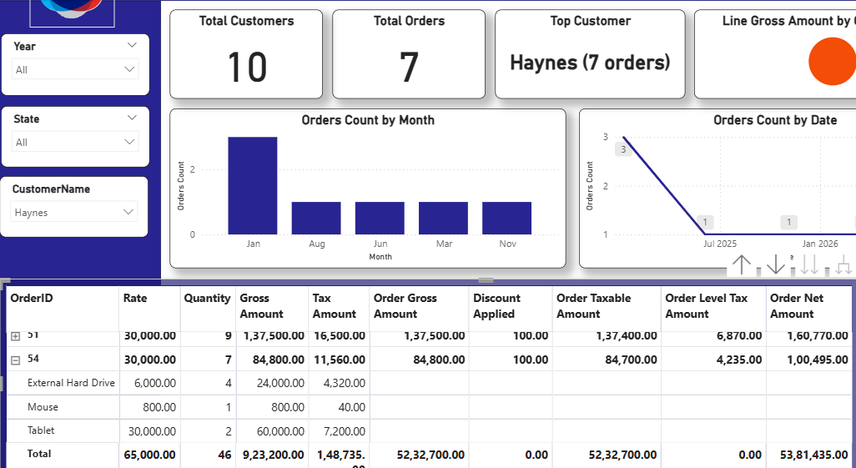

- Develop a forecasting report that showcase what is the likelihood that customer name Haynes is going to buy a Product
An Area Chart predicts the probability that a selected customer—e.g., Haynes—may purchase a product again.
This prediction is based on:
- Historical purchases
- Frequency
- Recency
- Product affinity
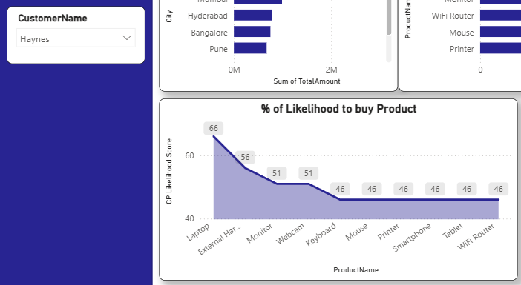
Hovering on any data point displays a tooltip with historical trend details.
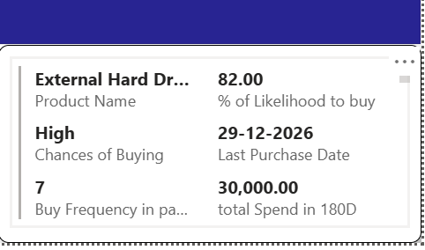

- Develop a forecast report that based on customer’s demands how much quantity of a product needs to be procured so that their demands can be fulfilled.”
A Line Chart shows historical order quantities and forecasts for the next 1 month.
The visual also displays stock sufficiency to indicate whether available inventory can meet expected customer demand.
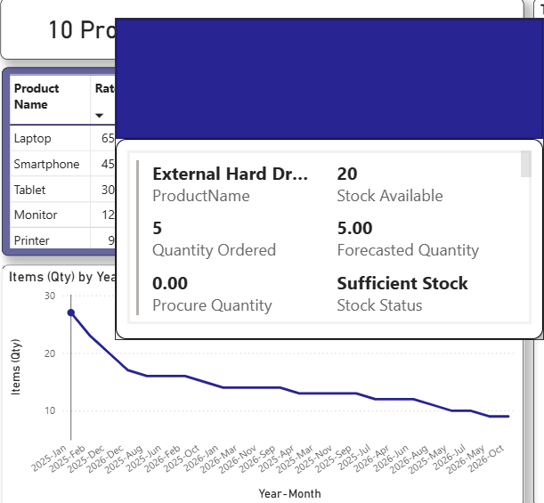

- List out products that are not taxable:
A KPI card shows the total number of products.
Hovering over it reveals a tooltip listing taxable vs. non-taxable products
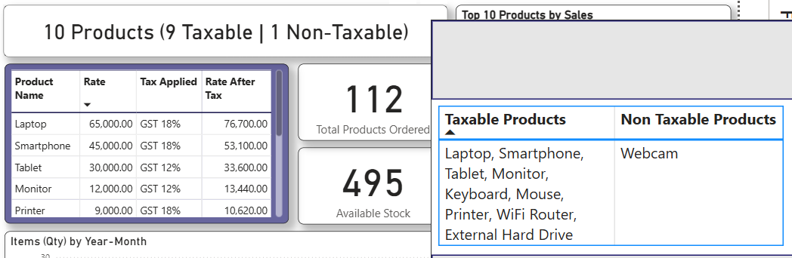

- List out Orders as to “Why” tax is not applicable:
A table visual lists all orders where tax is not applied.
Common reasons include:
- Product falls under GST Exempt
- Tax ID is null
- Product is marked as non-taxable
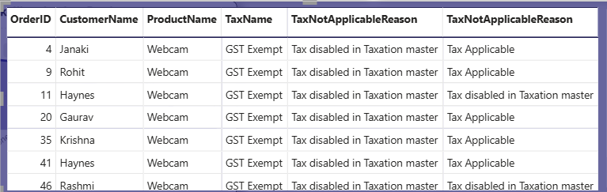

- Extra Visuals Added
1. Customer Summary Card
Displays:
- Total Customers
- Total Orders
- Top Customer (highest order count)
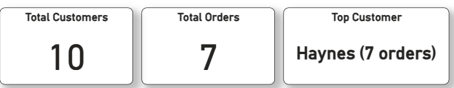

2. Product Volume & Stock Card
Shows:
- Total products ordered in the selected year
- Current available stock
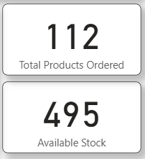

3. Top 10 Products by Sales
A bar chart ranking products by revenue contribution.
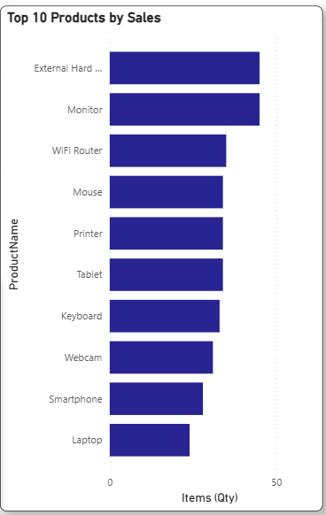
4. Total Sales & Total Discount
Two KPI visuals showing:
- Total Sales (excluding tax and discount)
- Total Discount applied across orders
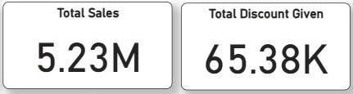

5. Top 10 Cities by Sales & Top 10 Products Ordered
Paired charts showing:
- Highest revenue-generating cities
- Highest-demand products
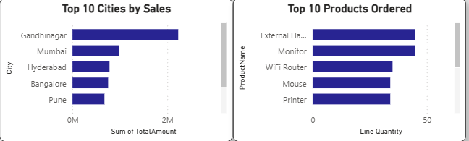
6. Location-wise Orders (Map Visual)
A map where bubble size represents the number of orders placed from each location.
